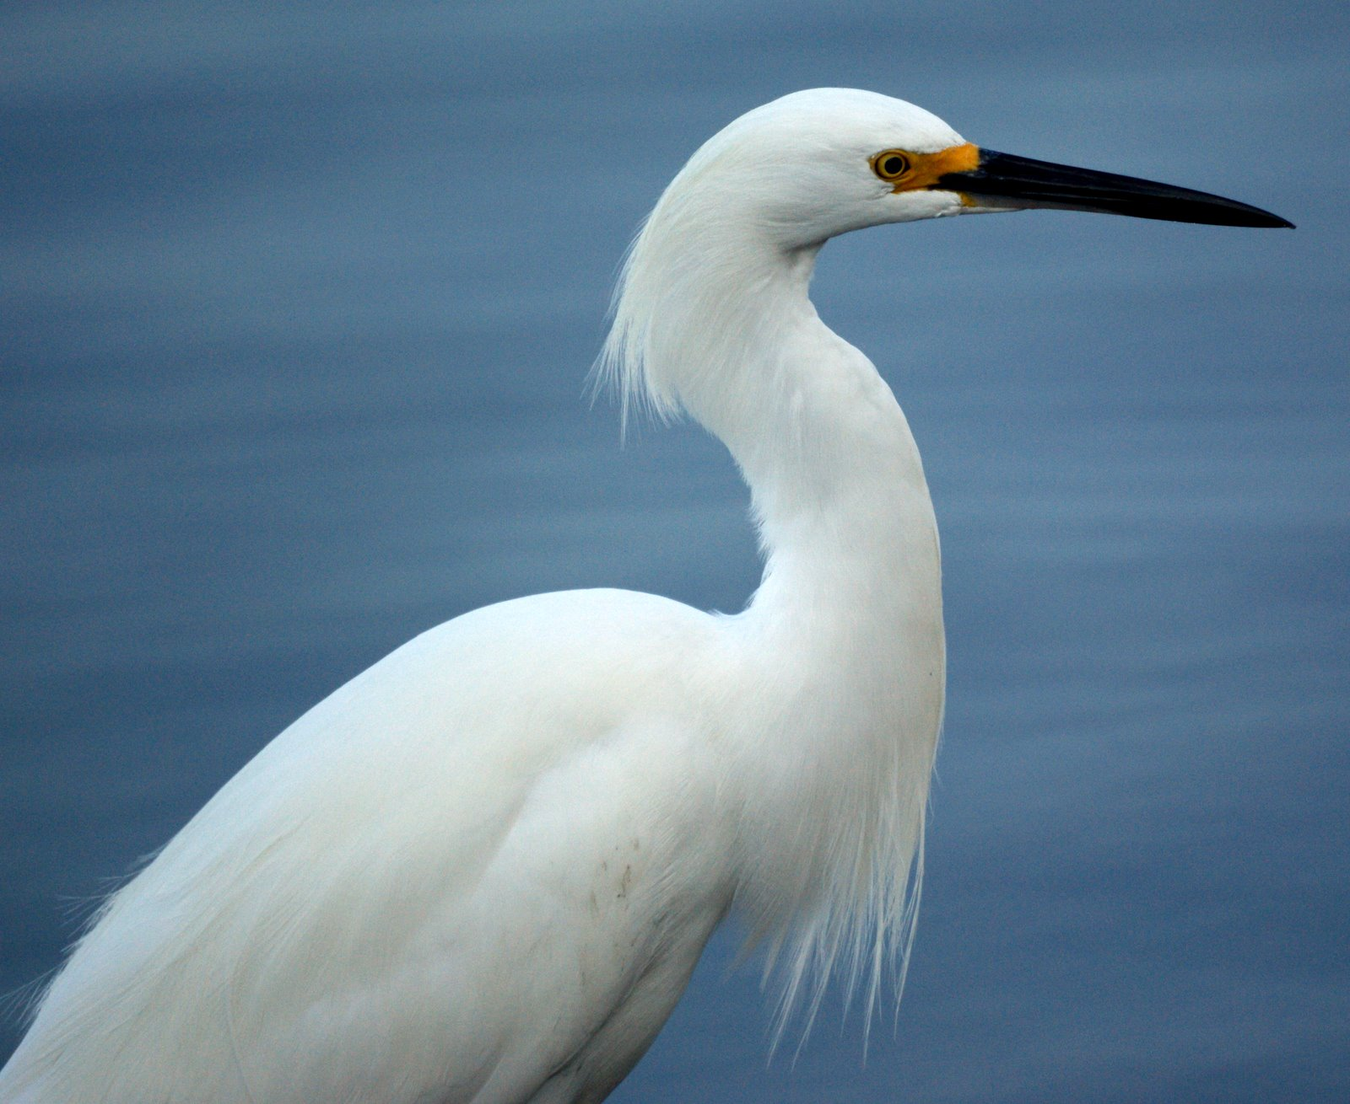

- Hey y’all: Bird Enthusiasts, Spring’s a-comin’!

- Once again Minerva’s is planning something special for YOU!

- May 1-3: A VISIT WITH NEW JERSEY’S BIRDS !!
Friday night supper at Minerva's (Emma and Paul will serve breads, soups, salad and dessert.) We'll get to know each other and our favorite birds.
- Bring your favorite photos, your favorite birding stories, your cameras, your ‘scopes, and your enthusiasm!!
Saturday morning: After breakfast we'll grab our cameras and notebooks and head for the Barnegat Light jetty and/or to the Forsythe National Wildlife Refuge, accompanied by our own special guide: a bird-and-wildlife-protection expert from the Rutgers University Department of Ecology, Evolution, and Natural Resources, who will provide extra scopes, field guides, and expertise for a fascinating morning of birding.

You'll be delighted to meet our guide, Michael Allen, Ph.D (who is a colleague of our beloved Professor Brooke Maslo, who oversees the plover-nesting area in Barnegat Light, and has sometimes led Minerva’s birding weekend.)
Michael has mesmerized us for the past two years with his expertise and easy-going, can-do presentation style, and we’re delighted that he’s returning!

It’s gonna be another not-to-be-missed weekend…….

(If it rains—and maybe even if it doesn’t—we have indoor AV equipment and a projector for “virtual” birding)
- For more info on the Forsythe Refuge, see https://en.wikipedia.org/wiki/Edwin_B._Forsythe_National_Wildlife_Refuge

- Saturday evening: Emma and Paul will make a scrumptious supper and we'll plan our local bird-walking for after…

- …Sunday morning breakfast.

The cost for all this lodging, food, and fun? $195/person, single; $140/person if you’re sharing a room; first child under 12 FREE; ($79/child for second or more)

