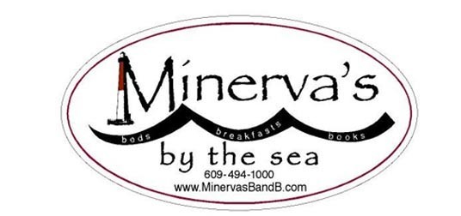 13 West Seventh St—Barnegat Light NJ 08006
Ph: 609-494-1000 Txt: 610-653-6153
November 1-3, 2019: Writers' All : Novices and Pros Retreat.
Looking to grab yourself some designated writing time?
Looking for a chance to hang out with other writers
who share your perspectives on life and words?
This could be for YOU!
Kimberly Nagy -- author, editor and coach--loves helping aspiring and established writers discover, rediscover and deepen their authentic voice. An active member of the American Society of Journalists and Authors, she has shepherded many authors from their good ideas to refined, structurally-sound articles, essays, brochures, and award-winning book-length projects. Besides hiding out in bookstores and/or talking about philosophy over waffles and coffee at Minerva’s Bed & Breakfast, Kim’s passion is digging up stories about women and their quests. She has interviewed Pamela Tanner Boll (Academy-Award winning filmmaker) and MacArthur Genius author Edwidge Danticat. among others.
Kim will lead a Saturday session to help writers gain traction and insight on their current works-in-progress in a friendly and supportive workshop setting. Even the most experienced of writers can sometimes feel lost-in-the-thicket of their notes, thoughts and inspirations. Whether your project is an essay, a book chapter, a memoir or a poem, Kim’s coaching expertise will support your pursuit of the Muse with both encouragement and guidance.
Emma Lapsansky, who has published in an academic venue every year since 1981--and has been editing manuscripts as well as teaching novice writers for more than a decade-- will work with our group on techniques for keeping the writing muscles “loose” as well as durable and resilient.

Check out Kim's interview with Emma Lapsansky, owner of Minerva’s Bed and Breakfast.
http://www.kimnagy.com/interviews/women-triple-quest/the-minervas-quest/
Read below for details about Minerva’s Writers’ Weekends:……

Here’s what a Minerva’s Writer’s Retreat looks like:
- Friday night soup-and-salad-and-dessert supper: get to know your weekend “housemates”
- Saturday morning hot breakfast, followed by a “writers’ warmup” session led by your facilitators
- Lunch and thinking/walking/writing time
- Late afternoon session with your facilitators
- Supper and informal exchanges with those “housemates” who “get it” about the writing process
- Early evening retiring to read short samples of your “housemates’” work
- Sunday morning breakfast with those “housemates” who are now your new “best friends”
- Sunday morning closing session to discuss “best friends” writing.
All-inclusive price: $260/person ($210 if you are sharing a room)
AND….if you’d like a little more time to take advantage of the head of steam you’ve built up, you can spend an extra night: the rate is only $70, including Monday morning breakfast!
Remember Minerva’s mantra: “Friends don’t let friends write alone.”

