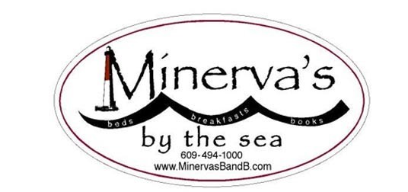 13 West Seventh St—Barnegat Light NJ 08006
Ph: 609-494-1000 Txt: 610-653-6153
March 20-22, 2020: Writers' All : Novices and Pros Retreat.
The January 2020 Writers’ Workshop begs repeating!!
So the wonderful Kim Nagy is returning in March!
Is this YOUR a chance to refocus, to escape distractions, and to reawaken your creativity?
Join us at Minerva’s for good food, good feedback, good company!
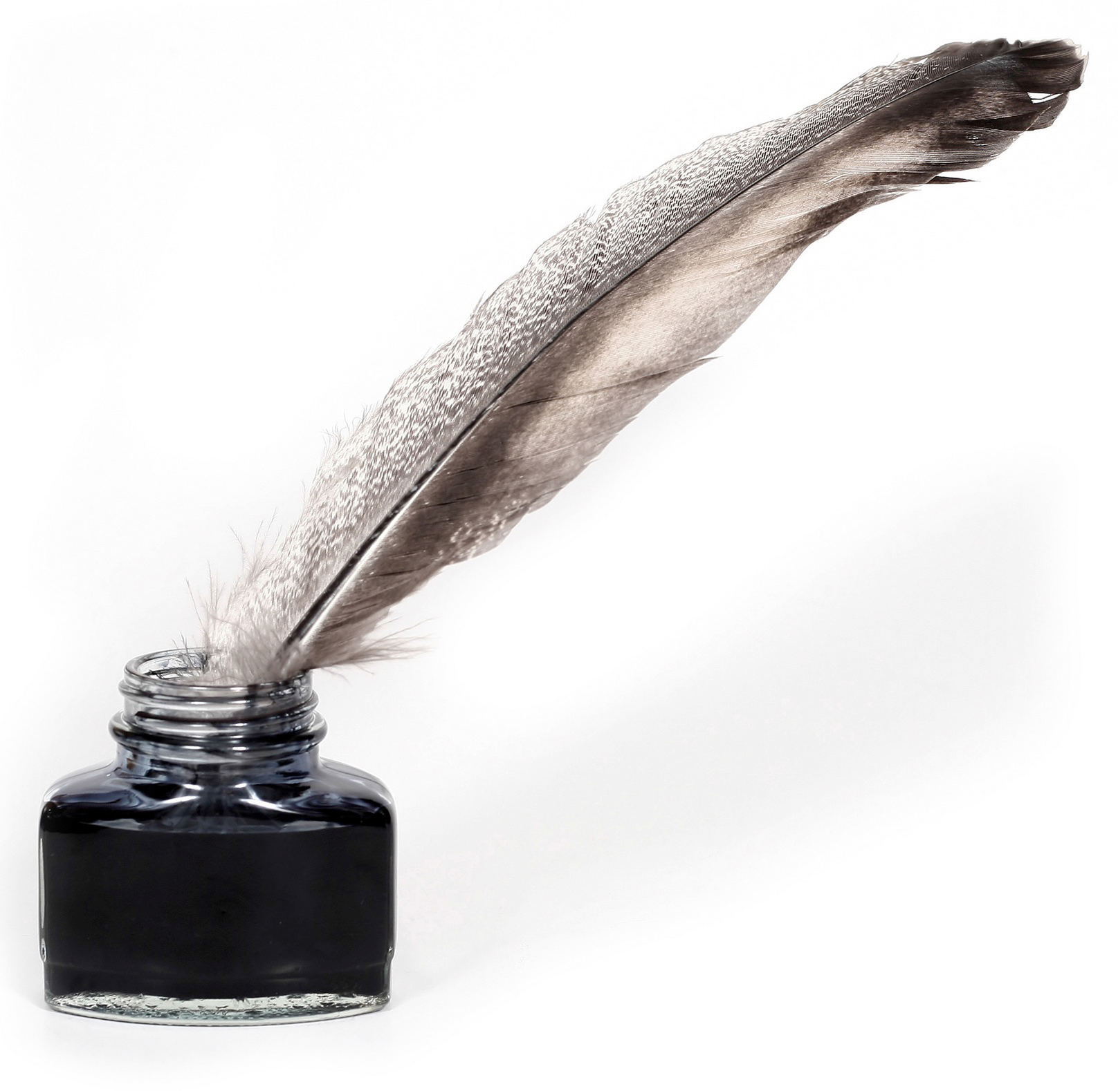
Kimberly Nagy – that wonderful author, editor and coach will be back!!
Check out Kim’s recently-published article on a surprising and inspiring woman!
https://blogs.scientificamerican.com/voices/the-woman-who-founded-industrial-medicine/
An active member of the American Society of Journalists and Authors, Kim has shepherded many authors from their good ideas to refined, structurally-sound articles, essays, brochures, and award-winning book-length projects. One of Kim’s passions is digging up narratives about women and their quests, and about “under-told” stories in general. But she also likes to publish her sensitively-crafted interviews with folks who are in the limelight: she has interviewed Pamela Tanner Boll (Academy-Award winning filmmaker) and MacArthur Genius author Edwidge Danticat among others.
Kim will lead a Saturday session to help writers gain traction and insight on their current works-in-progress in a friendly and supportive workshop setting. Whether your project is an essay, a book chapter, a memoir or a poem, Kim’s encouragement and coaching expertise can help guide your pursuit of the Muse.
Emma Lapsansky, who has published in an academic venue every year since 1981--and has been editing manuscripts as well as teaching novice writers for more than a decade-- will work with our group on techniques for keeping your writing muscles “loose.”

Check out Kim's interview with Emma Lapsansky, owner of Minerva’s Bed and Breakfast.
http://www.kimnagy.com/interviews/women-triple-quest/the-minervas-quest/
Read below for details about Minerva’s Writers’ Weekends:……

Here’s what a Minerva’s Writer’s Retreat looks like:
- Friday night soup-and-salad-and-dessert supper: get to know your weekend “housemates”
- Saturday morning hot breakfast, followed by a “writers’ warmup” session led by your facilitators
- Lunch and thinking/walking/writing time
- Late afternoon session with your facilitators
- Supper and informal exchanges with those “housemates” who “get it” about the writing process
- Early evening retiring to read short samples of your “housemates’” work
- Sunday morning breakfast with those “housemates” who are now your new “best friends”
- Sunday morning closing session to discuss “best friends” writing.
All-inclusive price: $260/person ($210/person if you are sharing a room)
AND….if you’d like a little more time to take advantage of the head of steam you’ve built up, you can spend an extra night: the rate is only $70, including Monday morning breakfast!
Remember Minerva’s mantra: “Friends don’t let friends write alone.”

