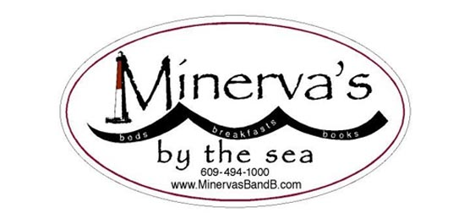

Fall 2022-Women’s Renewal Weekend

October 28-30, 2022
White Whale Motel -- 20 W. Seventh St Barnegat -- Light, NJ

Plan now for the Fall Women’s Renewal Weekend. !!

Make your plans to restore yourself with a manicure, pedicure, massage, yoga, psychic reading, art class… good conversation…and Minerva’s wonderful FOOD…?

Peruse the pages below….and then…

Contact us now to secure your reservation!

For more information, see below, or email <MinervasBandB@gmail.com>
Questions? call or text Emma’s cell at 610-653-6153!

As always, The weekend features our classic all-inclusive renewal prescription (YOU PAY One Gentle Rate, AND YOU GET IT ALL!):

$525 (single)-- (Double: $475/person)—includes lodging, four meals (two suppers/two breakfasts) , and all classes and services

Manicure and pedicure, massage, yoga, psychic reading, delicious breakfasts and dinners, a craft class, and of course the wonderful company of some amazing women.

BACK-AGAIN: Shindera Jackson, that dynamic NYC health coach/yoga instructor. Shindera is a student and colleague of Ghylian Bell, founder of the Urban Yoga Foundation, the mission of which includes “… creating a calming environment that addresses behavioral problems and stress-related disorders…. this non-profit agency seeks to equip young people with basic interaction and communication skills.” Learn more about The Urban Yoga Foundation at: https://docs.google.com/document/d/1XptIc_IG8kKzN7RDIF3JHbsIltyVNVQy_RuVSccPbHE/edit

>Massages will take place at Therapeutic Solutions in Barnegat Light!

>Tarot-card reader Colleen McNally will help us with our renewal weekend. Colleen comes highly recommended by Treacy Cantwell, whom some of you will remember fondly from prior Women Weekends.

>Erika Leeuwenburgh is returning to lead our art workshop! Some of you will remember our pleasure in her creative touch!

Please see next two pages for registration details and weekend schedule.

- Due with reservation—$100;
- Due September 15--$150
- Balance due on arrival. The good news!: No sales tax since this is a “special event”!
- ( *Gratuities not included)

To help us plan, please return the attached “preferences” form ASAP.

- Please email this form to MinervasBandB@gmail.com
(you may just copy and paste it into an email)

**Please return a separate sheet for each person, even if you're sharing a room. **

Name_________________________email_________________________________

1. Do you have food restrictions? (Are you vegetarian? Also please advise about allergies, such as cheese, eggs, dairy, sugar, salt, nuts, gluten, etc.)__________________________

2. The yoga teacher would like to know about your prior experience with yoga.

_____________________________________________________________________

3. What is your estimated arrival time? Afternoon____ Evening______ After 9_________

4. Please indicate the services you will want:

Massage yes____ no____ maybe_
Manicure yes____ no____ maybe___
Pedicure yes____ no____ maybe___
Yoga yes____ no____ maybe__
Astrology reading yes___ no____ maybe_______
Art class yes______ no_______ maybe________

Schedule of Relaxation

Friday:

  - 12 Check-in begins at 1 PM

  - 6:30 PM Supper

  - 8:30 PM Yoga /meditation

  - 6-9 Supper: Homemade soups, salad, bread, cheese &wine.

Saturday:

- 7:30 AM Yoga

- 9:00-10:00 AM Breakfast

- 10-5: Various yummy pamperings. (Your individual schedule will be in your arrival packet.)
- ** Snacks and juice will be available all day.
- ***Saturday lunch on your own. **

- 6:30 pm Supper: scrumptious vegetarian and non-vegetarian fare

Sunday:

- 7:30 am Yoga

- 8:30-10:00 AM Breakfast

- 10:30-12:00 Art class

- Check out early Sunday afternoon

And throughout the weekend, we will schedule your individual appointments for:

- Massages: Therapeutic Solutions

- Tarot readings: Colleen McNally

- Manicure and Pedicure will be at Red Sail salon in Surf City

