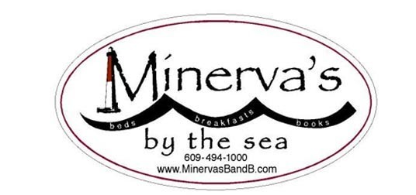 Charles Ostergren, world-class chef
Minerva’s TWELFTH Annual Gourmet Weekend
November 4, 2022
(To be held at the White Whale Motel
20 West Seventh St-Barnegat Light, NJ
(Limited to 10 guests: Deadline for reservations: October 1)

Is this REALLY number TWELVE???

So what happens at Minerva’s Gourmet Weekends?

First of all—we eat well:
- Friday evening: Emma’s homemade soups whenever you arrive
- Saturday morning: Minerva’s traditional yummy breakfasts augmented with
- A cheese demonstration which involves tasting
- Gourmet cheeses, accompanied by information about the birth, care, and enjoyment of well-bred cheese

Second, we think and talk about food.
- We exchange ideas about the ever-changing theories of what’s “good for us”, how researchers have arrived at those theories, and how to choose and procure “good” food. Welcoming back again the wonderful Ali Huber, that certified dietitian who talks about nutrition in language we normal people can understand—and suggests how to deploy food to optimize our body’s use of it.

Third, we enjoy a magnificent chef at work:
- Saturday evening supper: we watch Charles use—and talk to us about-- local ingredients while constructing our supper before our very eyes.

Fourth, between times, guests soak up the ambience of LBI and the ocean….How bad can this be?

Sunday, after another scrumptious Minerva breakfast, guests return home with a happy belly, some new recipes, some left-over cheese, some stimulating reading about food and nutrition, some memories of good conversation, and some renewed energy to face the winter….

Guests are still happy that the skinny little all-inclusive price for the weekend is only $410/person single. $379/person double. $340/person triple).
***We will repeat the same COVID protocols we used in 2021—which were so successful then (fingers crossed): asking guests to sign a waiver, test before you come, stay home if you’re sick (and we will refund!).
HEPA filter ventilators will be used in the dining room!**

For more information, call or text Emma at 610-653-6153

