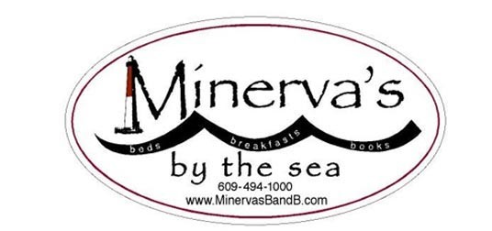 13 West Seventh St—Barnegat Light NJ 08006
Ph: 609-494-1000 Txt: 610-653-6153
January 17-19, 2020: Writers' All : Novices and Pros Retreat.
Is it time again to grab some writing time?
Looking for a chance to refocus, and to escape distractions?
Join us at Minerva’s for good food, good feedback, good company!
Kimberly Nagy – that wonderful author, editor and coach will be back!!
Kim describes herself as a woman who “loves helping aspiring and established writers discover, rediscover and deepen their authentic voice.”
An active member of the American Society of Journalists and Authors, Kim has shepherded many authors from their good ideas to refined, structurally-sound articles, essays, brochures, and award-winning book-length projects. One of Kim’s passions is digging up narratives about women and their quests, and about “under-told” stories in general. But she also likes to publish her sensitively-crafted interviews with folks who are in the limelight: she has interviewed Pamela Tanner Boll (Academy-Award winning filmmaker) and MacArthur Genius author Edwidge Danticat among others.
Kim will lead a Saturday session to help writers gain traction and insight on their current works-in-progress in a friendly and supportive workshop setting. Even the most experienced of writers can sometimes feel lost-in-the-thicket of their notes, thoughts and inspirations. Whether your project is an essay, a book chapter, a memoir or a poem, Kim’s encouragement and coaching expertise can help guide your pursuit of the Muse.
Emma Lapsansky, who has published in an academic venue every year since 1981--and has been editing manuscripts as well as teaching novice writers for more than a decade-- will work with our group on techniques for keeping your writing muscles “loose.”

Check out Kim's interview with Emma Lapsansky, owner of Minerva’s Bed and Breakfast.
http://www.kimnagy.com/interviews/women-triple-quest/the-minervas-quest/
Read below for details about Minerva’s Writers’ Weekends:……

Here’s what a Minerva’s Writer’s Retreat looks like:
- Friday night soup-and-salad-and-dessert supper: get to know your weekend “housemates”
- Saturday morning hot breakfast, followed by a “writers’ warmup” session led by your facilitators
- Lunch and thinking/walking/writing time
- Late afternoon session with your facilitators
- Supper and informal exchanges with those “housemates” who “get it” about the writing process
- Early evening retiring to read short samples of your “housemates’” work
- Sunday morning breakfast with those “housemates” who are now your new “best friends”
- Sunday morning closing session to discuss “best friends” writing.
All-inclusive price: $260/person ($210/person if you are sharing a room)
AND….if you’d like a little more time to take advantage of the head of steam you’ve built up, you can spend an extra night: the rate is only $70, including Monday morning breakfast!
Remember Minerva’s mantra: “Friends don’t let friends write alone.”

